Chao Kuang Piu College AY2019/2020 Work Plan
2019-02
Chao Kuang Piu College (CKPC) will continue to focus on our vision to inspire lifelong learning and encourage sustainable growth. In order to attain our vision, in the process of educating students, we are going to apply the following strategies:
- Growth through exploration – to inspire students to come out of their comfort zone and explore new possibilities;
- Team innovation – to provide space and resources to generate creativity;
- Enhancing soft skills through practice – to cultivate leadership quality and communication skill through organizing and participating activities;
- Diversification model – to promote diversified development and encourage interaction with students of different backgrounds;
- Community blending – to root from Macau and outreach to society and the Greater Bay Area.
When executing the strategies above, we created the “Community & Peer Education Architecture” shown in the picture below, in order to effectively exploit the advantages of UM’s “4-in-1” education model, and with close tie with faculties and Honors College.
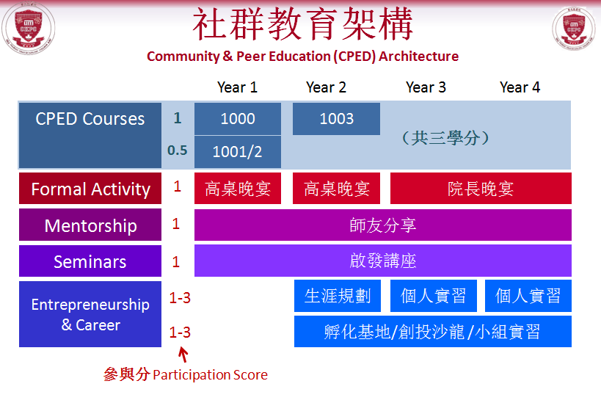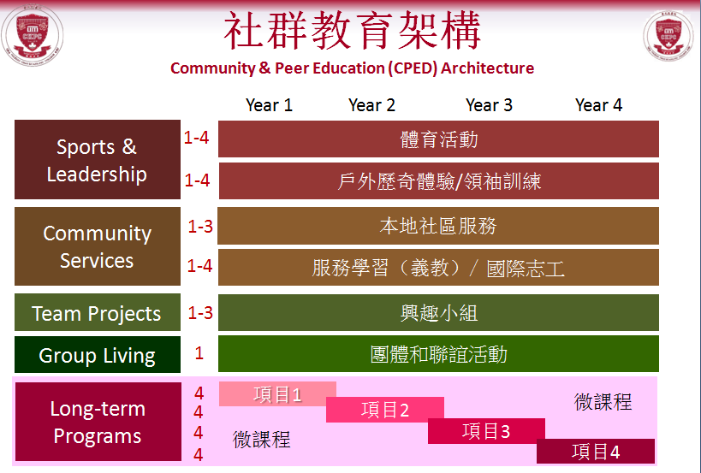
The “Community & Peer Education Architecture” includes the following elements:
Community & Peer Education (CPED) Courses – The courses guide freshmen to fit in college life through lectures and group activities.
Formal activity – Including High Table Dinner and Master Dinner etc. We are the pioneer of High Table Dinner 2.0 model. This model not only reduces the cost, but also introduces party themes which immensely motivate students to participate passionately. As for the guest speakers of High Table Dinner, we mainly invite people from local and Greater Bay Area, especially young people who are similar in age with students, to share their experience of striving for entrepreneurship and innovation, which could resonate more with students.
Mentorship – More than 50 mentors from different faculties act as the bridges for collaboration between college and faculties. These Affiliates and Fellows will mentor fresh college students and continue to develop more cooperation modes between college and faculties, as well as Honors College for group projects. In addition, we are one of the pioneers in campus to execute “Postgraduate Students Dining Pilot Program”, and “Residence for Postgraduate Students Program” to encourage maximum interaction with postgraduate students.
Seminars – We organize seminars every Wednesday and invite academic experts inside or outside UM to share various topics, aiming to broaden students’ vision and inspire interdisciplinary exchanges.
Entrepreneurship & Career – We provide space and resources to let our students build an entrepreneurship team and realize their creative ideas. The first college coffee shop on campus, “Infinite Coffee” has already become one of the iconic brands of CKPC. It also evolves to become a popular spot for student gathering. In the future, Infinite Coffee will continue to organize Coffee Workshop, English Hour, and cooperate with Master Kitchen to provide more services to our students. Another student-initiated project “Foodie Corner” was established to provide night snack for students and enrich students’ college life. We have also created an “Incubator Base” to let our students form interdisciplinary teams, practise team innovation, and make their dreams come true. For career development, we will organize career workshops, visits to corporations in the Greater Bay Area and co-organize internship programs with regional corporations. We will also organize Alumni Day every April. On Alumni Day, we allow our alumni to “come home” and learn about recent activities of college. It allows our students to learn the professional experience from our alumni.
Sports & Leadership – We will continue to encourage our students to participate all kinds of sports activities and promote experiential learning. The Me to We team successfully recruited 14 CKPC students as the first cohort, which is a new attempt to combine experiential education, outdoor adventurous education and community education. In the upcoming semester, the team will recruit new members as the second cohort. It is hoped that the senior members will guide the new members on the transformation of values and learn better than the traditional education system.
Community services – We will continue to optimize the utilization of our facilities to enhance cohesion between our students, especially local students. Activities include:
- 1001 Nights Reading Club and English hour every week
- Photography Class in the “Pi Production” studio every Tuesday, teaching students photography and making microfilm
- Movie Sharing in “Cinema i” every Friday, aiming to inspire students’ imagination and curiosity
- Students from the “Farmer Team” will continue to take care of the “Rooftop Organic Farm”, using the resources from IAM (Instituto Para Os Assuntos Municipais) for organic fertilizer from kitchen waste
- “Master Kitchen” is open for student groups and organize various baking workshops and healthy cooking workshops
Team and socializing projects – Our House Association will continue to organize various group and social activities to enhance the friendships of our students. These include orientation, festival celebrations, talent shows, etc. Our college cheerleading team, “Athena Cheerleading Team” will continue to perform and join competitions on campus. This will improve the team spirit of our students. College will continue to organize “College Roundtable”, a relaxing and informal sharing opportunity for students to share about their exchange program, study tour, and volunteering experiences.
Community service and exchange visit – We encourage our students to participate in Macau community activities. “Student Ambassador Program” provides an opportunity for Macau secondary school students to interact with college students and bring their experience back to their high school. CKPC conducted the first voluntary teaching tour to CongJiang, Guizhou last year. The group plans to provide voluntary teaching in June and December every year and produce “distance learning” video clips to enhance their study while the volunteer team is away. The team also plans to extend collaboration with Cheng Yu Tung College and Escola da Sagrada Familia. Through service learning, the volunteer students can improve their leadership capabilities, enhance their soft skills, and also elevate the image of UM in Macau community. Moreover, every year, we lead our students to visit Zhejiang University, Xi’an Jiaotong University and East China Normal University (included in the 10,000 scheme program), in order to foster the relationship between youngsters between Macau and mainland China.

